Name: _______________________________ Date: ____________________
Mrs. Plante / Ms. Spatz Science-8

Lab Write–Up
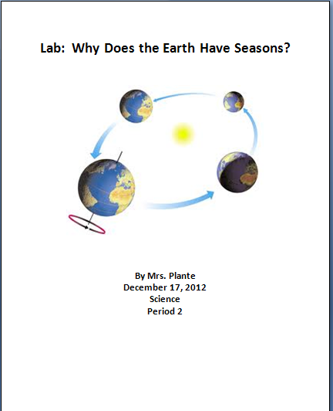
1. Cover Page:
- Include:
  - Title
  - Picture
  - Name
  - Date
  - Subject / Period

2. Procedure and Purpose Page:
- Purpose: The purpose of the lab is stated in a short, complete paragraph explaining the purpose of the experiment. (Generally 2 – 3 sentences)

- Procedure: This is a step-by-step explanation of what occurred during the lab activity. The detail must be clear enough for any person to follow your steps and reproduce the experiment. The steps may be written as a list with bullets or numbers.

3. Lab:
- Attach the lab packet to the end of your write-up.

