Name: ________________________________________ Date:_______________________
Mrs. Plante Earth Science

Phases of the Moon
When the Moon is getting bright, the light is on the right…

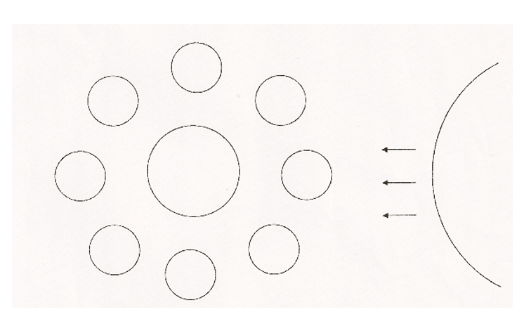
Directions: The diagram below represents the Earth as seen from space above the North Pole. Eight positions of the Moon throughout the month are shown.

- Label the Earth’s North Pole.
- Using arrows, indicate the rotation for the Earth and the Moon.
- Use arrows to show the direction of revolution of the Moon around the Earth and the Earth around the Sun.
- Draw the terminator on the Earth and on each position of the Moon.
- For each position of the Moon, label its phase.
- Below each label, draw a picture of the Moon as seen from Earth.
- Label “neap tide” on the two phases of the Moon where this occurs.
- Label “spring tide” on the two phases of the Moon where this occurs.

